**LEBANESE AMERICAN UNIVERSITY**

**USAID – HIGHER EDUCATION SCHOLARSHIP PROGRAM**

**HES - Volunteering Program Verification Form**

This form is to be used to document volunteering hours. If a student volunteers for multiple organizations, a separate form must be used for each organization. **This form must be turned in by the 28th of each month, the latest.**

I certify that the scholar Wissam Roaf Albahry completed a total of 5 hours of service at InnovaThrive.

The hours were completed hours as per the below:

Hours # 1 (date) _4/11 – 8/11_ (initials of supervisor) __A.K.___

Hours # 2 (date) _11/11 – 15/11_ (initials of supervisor) __A.K.___

Hours # 2 date) _18/11 – 22/11 (initials of supervisor) __A.K.___

Hours # 0 date) _25/11 - 29/11 (initials of supervisor) __A.K.___

Brief description of the activities the scholar performed or participated in:

I have conducted research about Artificial Intelligence (AI) in automated customer service solutions, focusing on how technologies like machine learning and natural language processing optimize efficiency and customer experience. Key applications include AI chatbots, automated response systems, and tools like Zendesk and Intercom. While AI improves availability and reduces costs, challenges such as maintaining a human touch and data privacy remain significant.

Written feedback about the scholar’s performance:

Wissam's research on AI in automated customer service demonstrates a strong grasp of key technologies like machine learning and natural language processing. His work highlights practical applications such as AI chatbots and platforms like Zendesk, showcasing his ability to analyze the balance between efficiency gains and challenges like maintaining personalization and data privacy. This depth of analysis reflects a commitment to understanding AI's transformative role in customer service, making Wissam a standout candidate

Please rate the overall performance of the scholar at your organization:

|  |  |  |  |
| --- | --- | --- | --- |
|  | Mastery (5) | Proficient (3) | Emerging (1) |
| **Problem solver** | X |  |  |
| **Engaged & Committed** | X |  |  |
| **Open-minded & multicultural** | X |  |  |

Signature

& stamp

__________________________

_

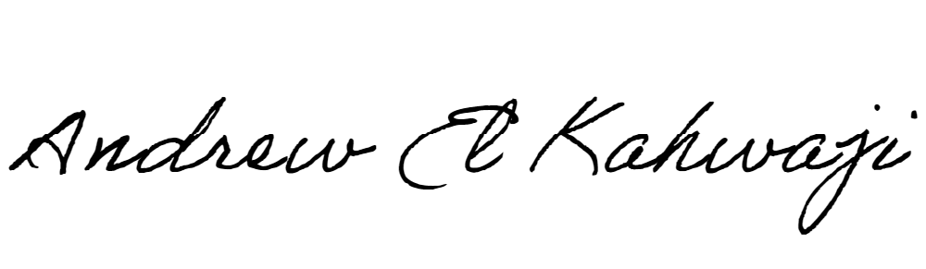

Printed Name _Andrew El Kahwaji_

Date __26/11/2024___

Email __andrew.lifesculptor.coo@gmail.com __

Phone __+961 71 914 378__

**LEBANESE AMERICAN UNIVERSITY**

**USAID – HIGHER EDUCATION SCHOLARSHIP PROGRAM**

